

**AHSANULLAH UNIVERSITY OF SCIENCE AND TECHNOLOGY**

Department of Computer Science and Engineering

**Project Name**: *Bow and Arrow*

Group members: 1.Soumik Das Bibon (**11.02.04.003**)

2.Md. Rezaunnabi(**11.02.04.016**)

3.Foisal Tushar(**11.02.04.020**)

Semester: 1-2

Section: A

Section group: A1

### FEATURES:

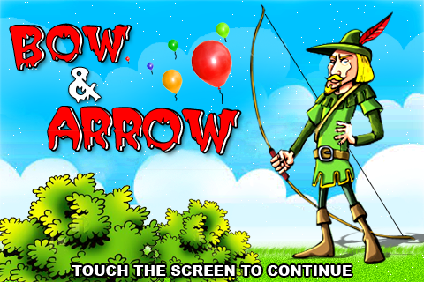

### NEW GAME

#### LOAD GAME

### SETTINGS

#### HELP

### ABOUT

#### EXIT

**New game**:  
 * Single player

**Load game**:

Start a previously saved game

**Settings**:  
*sound: sets the sound off or on

*music: a music that will be being played through the whole time

On

Off

*sfx: sound of Baloon hitting and arrow throughing etc.

On

Off

**Help**:

*instructions: how to play the game

*Levels: details about the levels after levels  
*History: The story on which the game is based on

**About**:

Info about the developers

**Exit**:

Exit the game window

**Game Objects**

1. Arrower: An arrower like Robin hood will stand by and will through the arrows

Arrower Size: Small and constant.

Arrower movement: Arrower will not move in level 1. But will move in level 2, 3 & 4.

Number of arrows: will defer with the increase of level

2. Balloons: The Balloons will move from down to up in a particular time gap.   
Size: Small/medium

Colour: Yellow, Red

Colour**:** Balloons colour will defer with the increase of levels. Colour will defer in level 2 and 3. And the arrower will lose One arrow for hitting each wrong balloons.

3. Arrow: The arrows will be shooted from the arrower….

Size: Small  
Hitpoints: same for all balloons

Colour: Same for all levels .

4. Butterflies: They will come out from the balloons after hitting the balloons in a particular level and will be vanished within a particular time.

Size: small  
Hitpoints: No hitpoints

5. Levels: 4 levels

6. Giants: They will come at the last level of the game

Movement: Right to left

Movement speed: Will increase with the time  
Damage: High

Colour: Deep green

LEVEL: 01

**Objective:** Hitting the balloons moving from down to up.  
**Location**: Green field

**Description**:

**An Arrower have to hit the particular balloon moving from down to up. The**

**number of arrows will be limited. The number of balloons will decrease with the**

**hitting.**

LEVEL:02

**Objective:** Hitting the Balloons but not the Butterfly.  
**Location**: Green field  
**Description**:

**Arrower have to hit the particular balloon moving from down to up. This time**

**butterflies will come out for hitting the balloons. And arrower will the number**

**of arrows for hitting the butterfly .**

LEVEL: 03

**Objective:** Hitting the Ballons But not the Wrong coloured balloon  
**Location:** Green field   
**Description**:

**Arrower have to hit the particular balloon moving from down to up. This time**

**arrower can not hit the wrong coloured balloon. Arrower will lose the number of**

**arrows for hiting the wrong coloured balloon. If he can not hit the balloon**

**within his number of arrow then the game will over.**

LEVEL: 04

**Objective:** Hitting the Giants coming to the arrower

**Location:** Green field

**Description**:

**In this level Giants will come to hit the arrower from right to left. They will**

**increase their speed with the time. The number of Giants will decrease with the**

**hit. But the number of arrows will be limited. If the Giants can touch the arrower**

**then Game will over.**